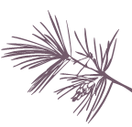
COCC Ponderosa Project Curriculum Development (2026)

Instructor: Sarah Fuller
Course: SUS 102, Introduction to Environmental Science
Course Description: Examines the science behind current environmental issues and sustainable solutions to problems. Focuses on ecological systems and case studies from Oregon and the Pacific Northwest. Labs may include field trips.
Course background: I developed and taught SUS 102: Intro. to Environmental Science for the first time in Fall 2023. This Fall 2025, I am teaching the course for the third time. The purpose of this Ponderosa Project funded work is to enhance the place-based sustainability lessons and activities developed in the first two iterations of the course. The course is designed as a general education science lab course which also articulated with Oregon State University’s SUS 102 course which is a required course for the Sustainability double Degree option at OSU.

Curriculum rationale
Supported by the Ponderosa Project, I developed additional activities over summer 2025 to enhance the curriculum. Specifically, I am adding four new activities to the course:

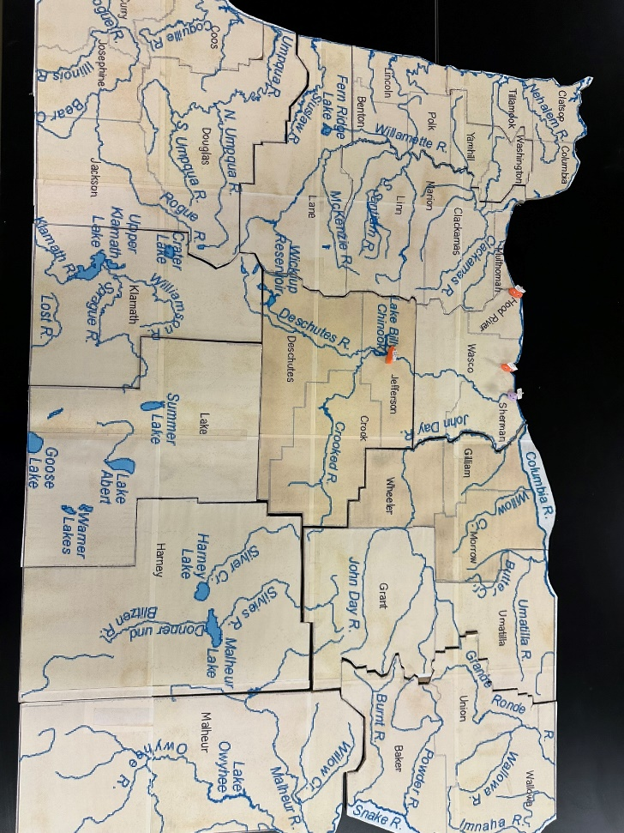
Activity 1 Oregon River Puzzle (Lab 2)
I designed and made six copies of a large-scale puzzle depicting the rivers in Oregon. Students work in small groups in the first week of the course to develop community with each other and identify the major rivers of Oregon, hydroelectric dams, and human communities in Central Oregon, as well as impacted cultural resources, such as Celilo Falls.
The purpose of the activity is to connect students to the regional landscape and encourage them to draw conclusions about the importance of local water resources to human society.

Activity 2 Watershed Model (Lab 3)
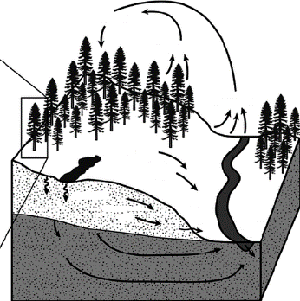
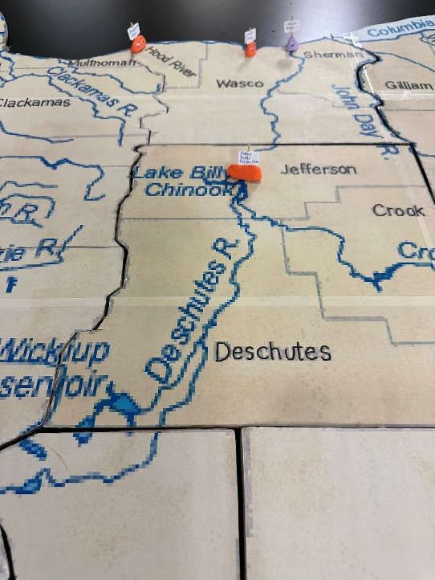
In week 3 of the course, I have a lesson about land-use cover in watersheds and water quality as a precursor to our local water sampling and water quality analysis activity. The students analyze maps showing the quality of water as it correlates to land cover in the U.S. Land use categories include undeveloped, agricultural, and urban as well as site specific contaminant sources such as mining, oil/gas extraction, wastewater treatment plants, and livestock facilities. We also study how forested watersheds interact with the water cycle and supply clean water to human communities.

This new hands-on activity will have students construct model watersheds to investigate water flow across the landscape with and without model “trees” and develop a sense of how the landscape interacts with our water supply in a 3-dimensional system.
Students will make predictions and observations about the impacts of wildfire and clearcutting on infiltration, streamflow, and erosion.
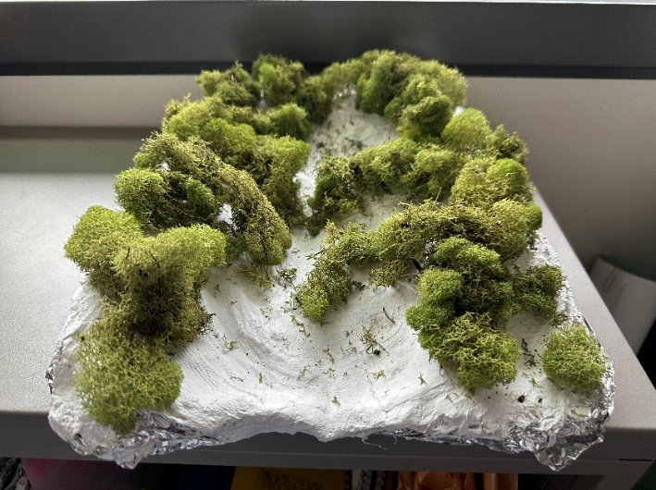
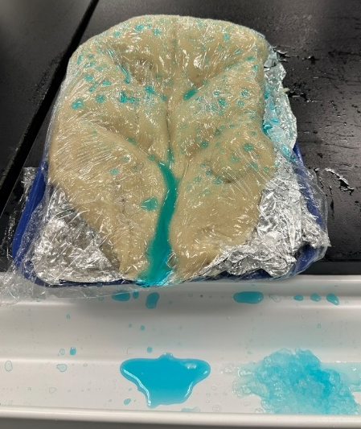

Activity 3 Contaminants in Water and Filtration (Lab 4)
This activity will enhance the depth of Lab 4 by challenging students to filter out “contaminants” from water. The activity will help students realize that preventing contamination of our water supply is a more cost-effective strategy than removing unwanted materials such as nutrients, PFAS (forever chemicals), etc.
In Part 1 of the activity students experiment with a variety of filtration materials: gravel, coffee filters, soil, sand, cotton, charcoal, and cheesecloth to observe collaboratively what they can filter from a sample of “contaminated” water. In Part 2 of the activity students will design a filter to attempt to return the water to a clear and odor free state.
Acknowledgements: Logan Aisling, Adjunct Chemistry Instructor, worked out details of this activity for our STEM Summer Science Camp and is generously sharing his work with me to incorporated into my SUS 102 course. Images are from S. Fuller taken during the science camp June 2025.

The Water Filtration Challenge (Part 1)
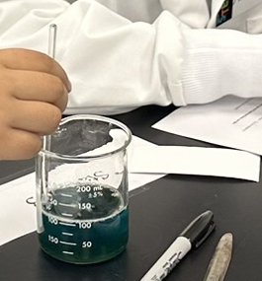
- Describe the polluted water in the beaker. What do you see? What do you smell?
- Stir the polluted water in the beaker. Add any new observations in the space below.
- Look at the sample of polluted water in the test tube. While holding the stopper in place, shake it up. Add any new observations in the space below.
- What type of filter material do you have? (Find your group number in the data table on the dry erase board.)
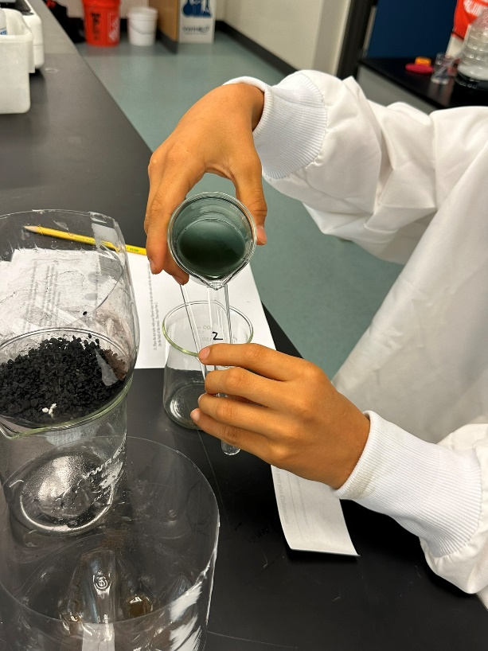
- Stir the polluted water in the beaker again and slowly add it to your filter. Try to remove everything from the beaker.
- Describe the filtered water. What do you see? What do you smell?
- Stir the filtered water and add a sample to an empty test tube with your group’s number on it. Fill the test tube about ¾ of the way. Then put the stopper in place.
- While holding the stoppers in place, shake up the polluted water sample and the filtered water sample at the same time and examine them side by side. For differences in color, it helps to hold them against a white background with plenty of light. Add any new observations about your filtered water in the space below.

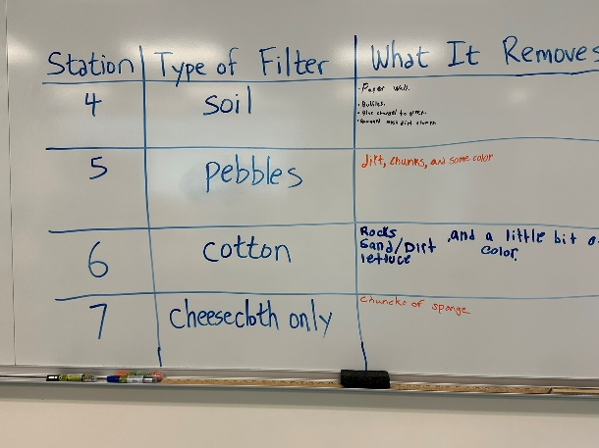
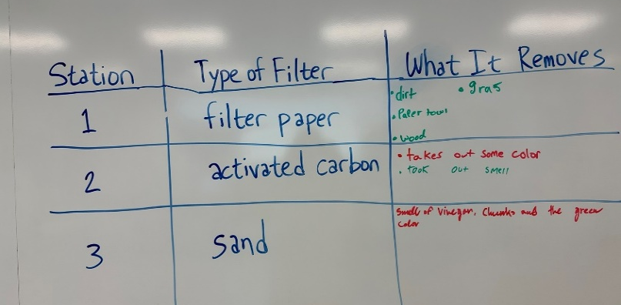
- List all of the types of pollution that your filter removed. Then add this information to the data table on the dry erase board.

- Place the test tube with your filtered water in the test tube rack with the other team’s samples (in the back of the room). Then begin Part 2.
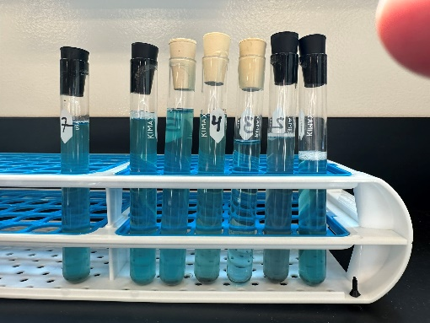

The Water Filtration Challenge (Part 2)
Now you’ll use everyone’s data to design the best water filter. Examine all the samples in the back of the room. Shake them up and compare them side by side if necessary.
- Using your observations of the samples and the classroom data on the dry erase board, decide which filter materials to use in your design. You may use as many materials as you want. If you choose to use activated carbon, read the special instructions provided. In the table below, write each material you’ll use and the reason for your choice.
Type of Filter Material | Reason for Choice

- Obtain all the materials you need from the stock tables on either side of the room. You may reuse the material currently in your filter, but run some clean tap water through it first to remove any pollutants.
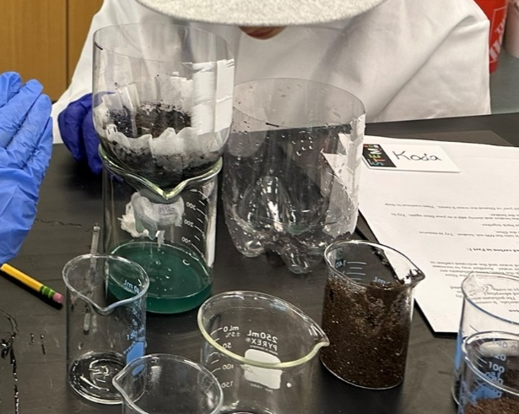
- If you aren’t using the old filter material, empty it into a trash can and rinse out your filter. Do not remove the cheesecloth!

- Add your materials to the filter. You’ll need to decide whether to layer them, mix them, or use some combination of the two. If you’re using activated carbon, think about how to increase the contact time with the polluted water. It may not be practical to re-filter the water by doing multiple pours.
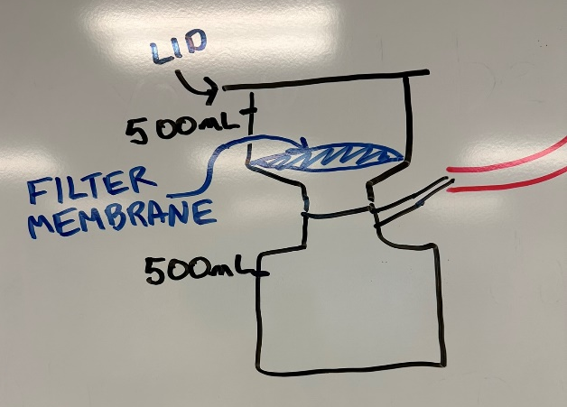
- Draw a picture of your design in the space below. Label all the components.

- Obtain a new sample of polluted water from your instructor.
- Add all of the sample to your filter. Try to remove everything from the beaker.

- Describe the filtered water. What do you see? What do you smell?

- Stir the filtered water and add a sample to an empty test tube with your group’s number on it. Fill the test tube about ¾ of the way. Then put the stopper in place.

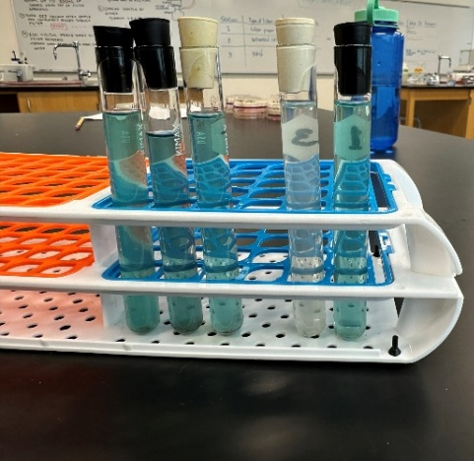
- While holding the stoppers in place, shake up the polluted water sample and the filtered water sample at the same time and examine them side by side. For differences in color, it helps to hold them against a white background with plenty of light. Add any new observations about your filtered water in the space below.

- Did your filter perform as expected? Explain.

- If enough time remains, redesign your filter and test the new design.

- Place your best filtered sample in the test tube rack designated by your instructor.

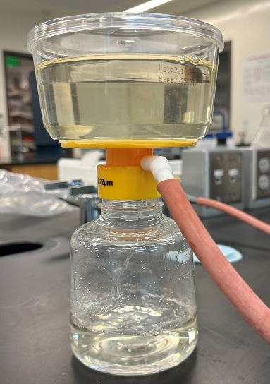
Activity 4 PFAS and Microbial Water Testing (Lab 5)
This activity will enhance the depth of Lab 5 by expanding the water analysis from water samples gathered by students from Hatfield Pond and Bridge Creek. Formerly the lab involved testing from nitrates using a green chemistry technique. This revision adds microbial testing and a discussion of PFAS testing of effluent from our wastewater treatment effluent at Hatfield ponds.
Students filter water through a microbial filtration device and plate a small sample on bacterial growth media to detect presence of fecal coliform bacteria.

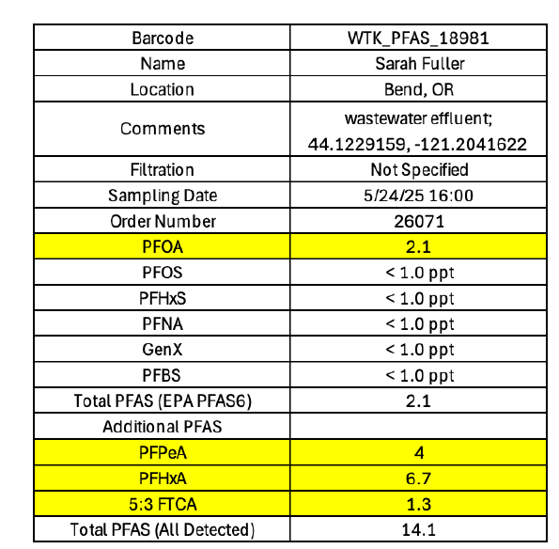
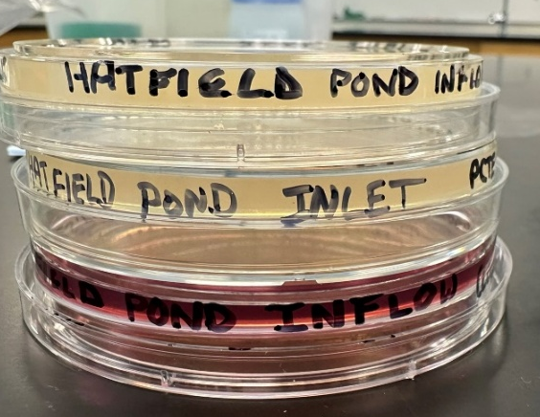
Due to the expense and time constraints for PFAS testing of water released at the Bend Wastewater reclamation facility – testing was conducted this summer and the results will be analyzed and interpreted by students.

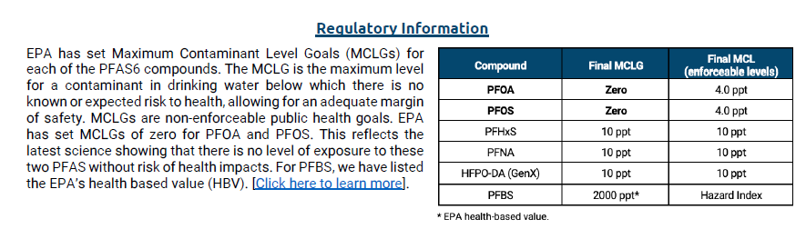

Week | Tuesdays Lecture and Lab  1-2:20 PM in MAZ 224 & 2:30-5:20 in MSC 160 | Thursday Lecture Only  1-2:20 PM in MAZ 224
1 | Introduction to the course  Oregon River Puzzle *¹  Watershed Model Construction *² | Rivers, Streams, & Fish
2 | Field Trip to Sawyer Park - Macroinvertebrates for monitoring water quality. | Watersheds
3 | Field Trip to Bridge Creek - Water Sampling | Water pollution
4 | Field Trip to Hatfield Ponds - Water Sampling & Filtration*³ | Microorganisms, Nutrient Cycling, & Soil
5 | Water Quality Analysis Nitrates, PFAS, and Microbes*⁴ | Midterm
6 | Field Trip to Pine Meadow Ranch - Regenerative Agriculture and Soil Sampling | Invasive Annual Grasses in Rangelands & Native Seed Restoration
7 | Lichens as bioindicators & Vehicle Emissions | Air Pollution
8 | Veterans Day – NO CLASS | Microplastic Pollution
9 | Microplastics Lab | PNW Marine Systems
10 | Ocean Acidification Lab | Thanksgiving – NO CLASS
11 | Plants & Pollinators  Seed processing & plant propagation | Review for Final Exam

Course Topics (*Enhanced Sustainability Course Activities supported by Ponderosa Project)

