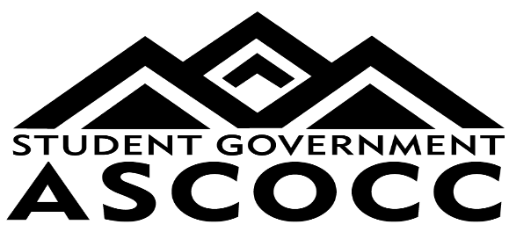

**ASCOCC COUNCIL MEETING**

DATE: October 29, 2024

LOCATION: ASCOCC Office, Coats 207

1. Call to Order/Roll Call
2. Approve Agenda-
3. Approve minutes from 10/15
4. President’s Report- Thomas Wrisley
5. Special Orders:
6. Sophie- Thrive Central Oregon
7. Erika Russel- Presidential Search Advisory Committee
8. Officer Reports:
9. Dir. Student Affairs- Hannah Evenson
10. Dir. Campus Affairs- Talia Stockwell
11. Dir. Financial Affairs- Benny Garcia
12. Internal Affairs Coordinator- Anna Robinson
13. External Affairs Coordinator- Raymond Salinas
14. Wickiup Liaison- Londale Dhesi
15. Redmond Campus Liaison- Neil Weiss
16. Office Coordinator- Betsy Green
17. Committee Reports:
18. GOTV Committee- Thomas, Talia, Neil, Olivia
19. Student Healthcare Committee- Hannah, Londale, Raymond
20. Unfinished Business
21. Council Goals, 2024-2025
22. New Business
23. Changes to ASCOCC Bylaws and Constitution- Thomas Wrisley
24. Announcements
25. Adjourn