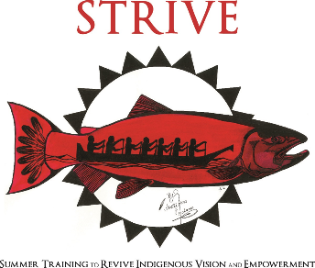
Packing List - What to Bring?
You’ll be at STRIVE for 3 nights and 4 days so try to bring clothing for this amount of time. Please bring appropriate clothing for the various activities –walking to class and on field trip, gym/free time, team building activities, and Closing Dinner. Remember, you’ll be attending college level classes, so dress appropriately!
Here is a list of items you may want to bring:
- Pants and/or shorts
- T-shirts
- Jacket/Layers
- Sweatshirt
- Underclothes (including socks)
- Bathing suit/comfortable clothes for swimming
- Something to sleep in
- Sneakers/ comfortable clothes for hiking
- Comfortable shoes for day-to-day use
- Shoes you’re okay getting wet
- Toiletries (toothbrush, toothpaste, soap)
- Water Bottle
- Towel for showers
- Beach towel/towel for field trip
- Pillow (other bedding will be provided)
- Nice clothes for the Closing Dinner (whatever clothing feels special or celebratory for you)
If you are unable to bring what you need, please contact Jackie Currie as soon as possible-- we do have money to help with anything you may be missing, no questions asked. We want you to be comfortable and enjoy your week!
Call or email if you have any questions.

Jackie Currie
Native American College Prep Coordinator
Office: (541) 330-4369
Email: jcurrie@cocc.edu

