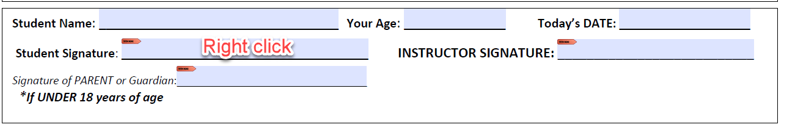
If you have not set up a Signature line before, do so now. You should receive these popups.
Choose New Digital ID
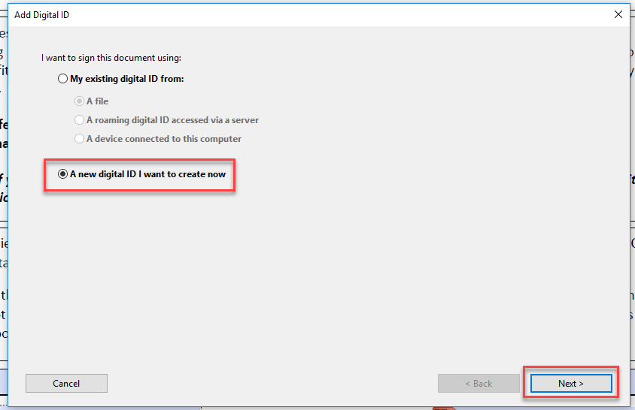
Choose Windows Certificate Store
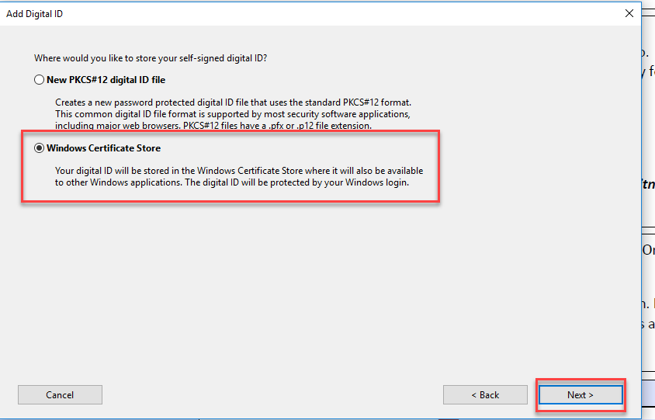
Fill out as much information as you’d like to have for your profile.
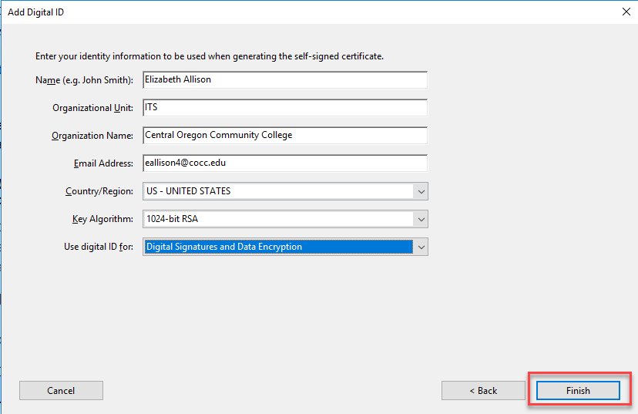
The default is a Standard Text. When you digitally sign, it will stamp your name, the time, date and logo as shown below.
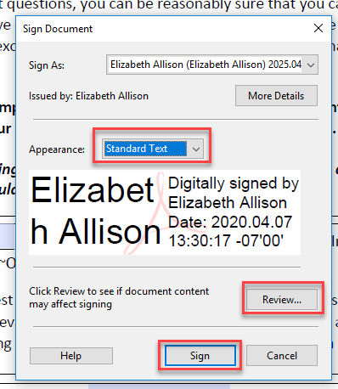
You can change the appearance of your signature by clicking Standard Text, and clicking Create New Appearance:
If you only want to show your name, and none of the other stamp, make these changes to this popup:
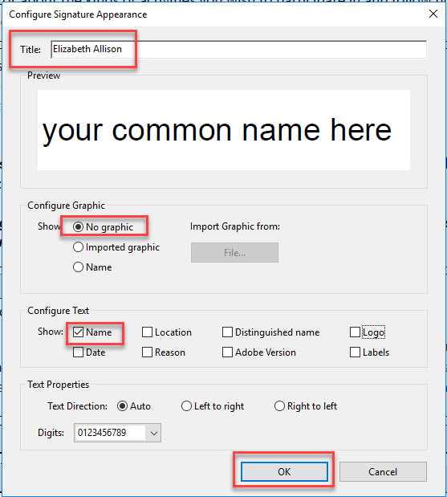
Review this is how you want your signature to look when you sign.
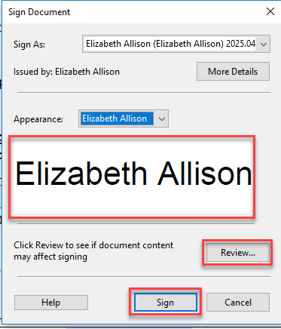
Click the Review button to make sure the formatting will not change the integrity of the form:
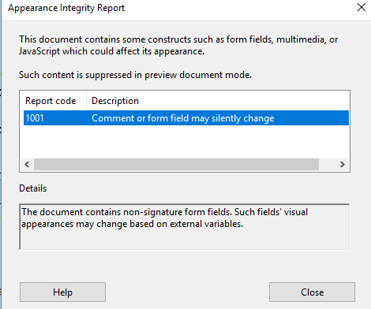
Click Close then Click Sign.
This will not show your signature but will save a PDF with your signature. Rename and save to a folder on your computer. Here is where I have saved mine:
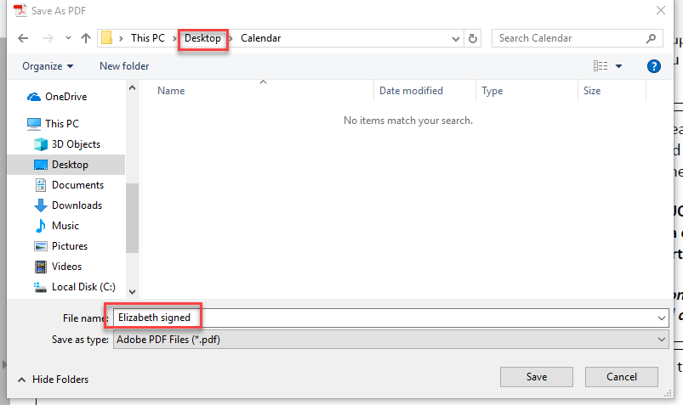
Open your PDF and you will find your signature attached to the saved PDF.
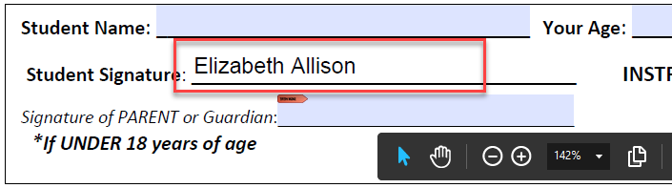
If you are not satisfied with your signature, you may change it by Right-Clicking the field and choosing “Clear Signature”.
I have decided to choose the Standard Text to sign. Here is how that would look:
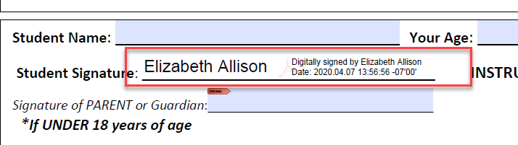

If you’d like to create a signature. Open the Paint app on your computer. Using your mouse, sign your name and save as a .jpg.
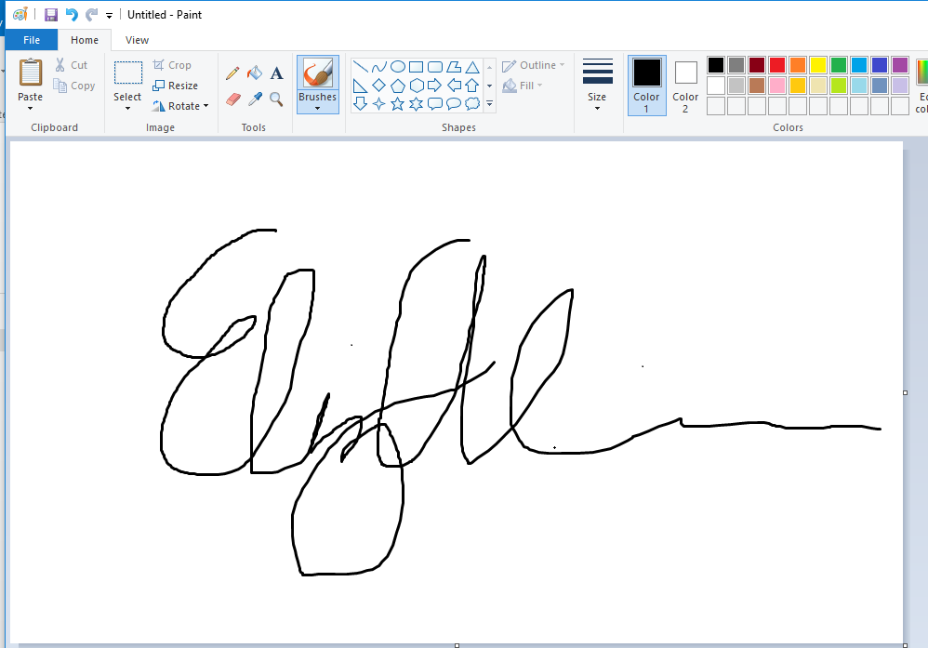
In your PDF use the Standard Form dropdown and Create New Appearance and fill in like so:
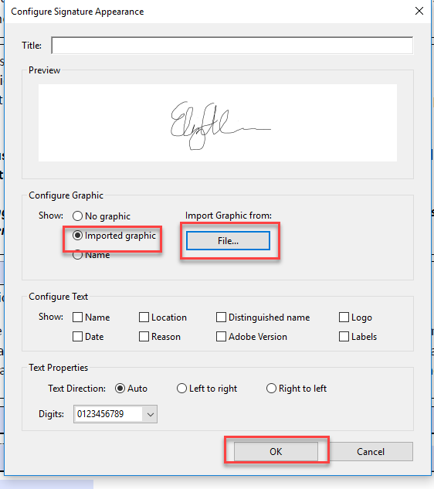
After you save it will look like this:
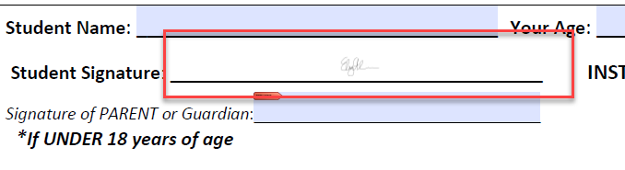
You may need to play with the size a bit until it’s what you’d like.

